BCSE498J CAN BE A GROUP PROJECT OF MAXIMUM THREE MEMBERS
1ST & 2ND PAGE LIST ALL THE TEAM MEMBERS
DECLARATION PAGE, CERTIFICATE PAGE & ACKNOWLEGEMENT PAGE ENTER ONLY YOUR NAME.
(EVERY INDIVIDUAL HAS TO SUBMIT THE PROJECT REPORT)
NO GROUP SUBMISSIONS
The sequence in which the project report material should be arranged and bound should be as follows

- Cover Page
- Title Page
- Declaration by the Candidate
- Certificate
- Certificate by External Guide (Applicable only for PAT discontinued students – if Applicable)
- Abstract
- Acknowledgement
- Table of Contents
- List of Tables 10.List of Figures
11.List of Symbols, Abbreviations and Nomenclature 12.Chapters of the Report
13.Conclusion & Future Work 14.References-APA FORMAT 15.Appendices

The dimension of the project report should be in A4 size.

PAGE SPECIFICATIONS

Left Margin : 3.81 cm
Right Margin : 2.54 cm
Top Margin : 2.54 cm
Bottom Margin : 2.54 cm
The project report should be bound using flexible cover with below mentioned colored art paper. The cover should be printed in black letters and the text for printing should be identical.

Color of Art Paper | Total Number of Pages in the Report
White | Mini. of 60 - Max of 100

Page numbers

All text pages as well as program source code listings should be numbered using Arabic numerals at the bottom center of the pages.
Font
Times New Roman 12pt font should be used consistently throughout the text. Captions for tables and figures can be in smaller fonts, but not smaller than 10pt.
Paragraphs

No paragraph should have its opening line at the bottom of a page. A clear, consistent, but not too large a separation must be provided between the paragraphs throughout the thesis.
Headings

Chapter Heading – Font Size: 16, Bold, Times New Roman Section Heading – Font Size: 14, Times New Roman, CAPS
Subsection Heading – Font Size: 12, Times New Roman, CAPS
Line spacing

The line spacing used should be the same throughout the text, and can be chosen to be between one and a half. The lines in captions for figures and tables, Table of Contents, List of Figures, and List of Tables can be single spaced, if desired.
A project report on
<Times New Roman, Font 12, Italic>

TITLE OF THE PROJECT REPORT
<Times New Roman, Font 20, Bold, CAPS>

Submitted in partial fulfillment for the award of the degree of
<Times New Roman, Font 14, Italic>

Bachelor of Technology in <<PROGRAM NAME WITH SPECIALIZATION NAME>>
<Times New Roman, Font 22, Bold>

by
<Times New Roman, Font 14, Italic>
NAME OF THE CANDIDATE (Reg. No.)
(IF TEAM PROJECT MENTION ALL MEMBERS NAME & REG NO)
<Times New Roman, Font 16, Bold, CAPS>


SCHOOL OF COMPUTER SCIENCE AND ENGINEERING

<Times New Roman, Font 16, Bold, CAPS> April, 2026
< Times New Roman ,Font size 12>


DECLARATION
<Times New Roman, Font 14, Underlined, Bold, CAPS>

I hereby declare that the thesis entitled “TITLE OF THE PROJECT” submitted by NAME (REGISTER NO), for the award of the degree of Bachelor of Technology in Computer Science and Engineering, Vellore Institute of Technology, Chennai is a record of bonafide work carried out by me under the supervision of Guide Name.
I further declare that the work reported in this thesis has not been submitted and will not be submitted, either in part or in full, for the award of any other degree or diploma in this institute or any other institute or university.
<Times New Roman, Font 12 >

Place: Chennai
Date: Signature of the Candidate
<Times New Roman, Font 12, Bold >



School of Computer Science and Engineering

CERTIFICATE

This is to certify that the report entitled “<project title>” is prepared and submitted by Name (Reg No) to Vellore Institute of Technology, Chennai, in partial fulfillment of the requirement for the award of the degree of Bachelor of Technology in <<PROGRAM NAME>> is a bonafide record carried out under my guidance. The project fulfills the requirements as per the regulations of this University and in my opinion meets the necessary standards for submission. The contents of this report have not been submitted and will not be submitted either in part or in full, for the award of any other degree or diploma and the same is certified.

Signature of the Guide:

Name: Dr./Prof.

Date:

Signature of the Examiner Signature of the Examiner
Name: Name:
Date: Date:

Approved by the Head of Department,
(MENTION PROGRAM NAME with SPECIALIZATION)

Name:(HoD NAME)

Date:

(Seal of SCHOOL YOU BELONG TO)

ABSTRACT
<Times New Roman, Font 14, Underlined, Bold, CAPS>

Electronic Business offers innovative ways of doing business through Internet. Internet revolution has introduced number of advanced technologies to access organizations all over the world in an efficient but simple manner. Intern et traffic is increasing exponentially as a result of wireless access, mobile computing and other innovative communication technologies.

<Times New Roman, Font 12>

i
ACKNOWLEDGEMENT

It is my pleasure to express with deep sense of gratitude to <Guide name>,
<Designation>, School of Computer Science and Engineering, Vellore Institute of Technology, Chennai, for his/her constant guidance, continual encouragement, understanding; more than all, he/she taught me patience in my endeavor. My association with him / her is not confined to academics only, but it is a great opportunity on my part of work with an intellectual and expert in the field of <area>.
It is with gratitude that I would like to extend my thanks to the visionary leader Dr. G. Viswanathan our Honorable Chancellor, Dr. Sankar Viswanathan, Dr. Sekar Viswanathan, Dr. G.V. Selvam Vice Presidents, Dr. Sandhya Pentareddy, Executive Director, Ms. Kadhambari S. Viswanathan, Assistant Vice-President, Dr. V. S. Kanchana Bhaaskaran Vice-Chancellor, Dr. T. Thyagarajan Pro-Vice Chancellor, VIT Chennai, Dr. K. Sathiyanarayanan, Director, Chennai Campus and Dr. P. K. Manoharan, Additional Registrar for providing an exceptional working environment and inspiring all of us during the tenure of the course.
Special mention to Dr. Viswanathan V, Dean, Dr. Nithyanandam P, Dr. Suganya G, Dr. Sweetlin Hemalatha C, Associate Deans, School of Computer Science and Engineering, Vellore Institute of Technology, Chennai for spending their valuable time and efforts in sharing their knowledge and for helping us in every aspect.
In jubilant state, I express ingeniously my whole-hearted thanks to <<HOD NAME>>, Head of the Department, B.Tech. <<PROGRAM NAME>> and the Project Coordinators for their valuable support and encouragement to take up and complete the thesis.
My sincere thanks to all the faculties and staffs at Vellore Institute of Technology, Chennai who helped me acquire the requisite knowledge. I would like to thank my parents for their support. It is indeed a pleasure to thank my friends who encouraged me to take up and complete this task.
Place: Chennai
Date: Name of the student
<Times New Roman, Font 12, Bold >

ii

CONTENTS
CONTENTS iv
LIST OF FIGURES ix
LIST OF TABLES xi
LIST OF ACRONYMS xii
CHAPTER 1 INTRODUCTION
  - INTRODUCTION 1
  - OVERVIEW OF MANET NETWORK 2
  - CHALLENGES PRESENT IN MANET 6
  - PROJECT STATEMENT 7
  - OBJECTIVES 7
  - SCOPE OF THE PROJECT 8
CHAPTER 2 BACK GROUND
  - INTRODUCTION 10
  - SURVEY ON MANETS 13
::

::

::

::

iii

LIST OF FIGURES
  - INFRA STRUCTURE BASED NETWORK 1
  - INFRA STRUCTURE LESS NETWORK 2
  - MOBILE AD-HOC NETWORK 4

iv
LIST OF TABLES
2.1 MULTIPATH ROUTING PROTOCOLS IN AMNETS 22
  - SIMULATION PARAMETERS 48

LIST OF ACRONYMS

MANET Mobile Ad hoc Network WAP Wireless Access Point


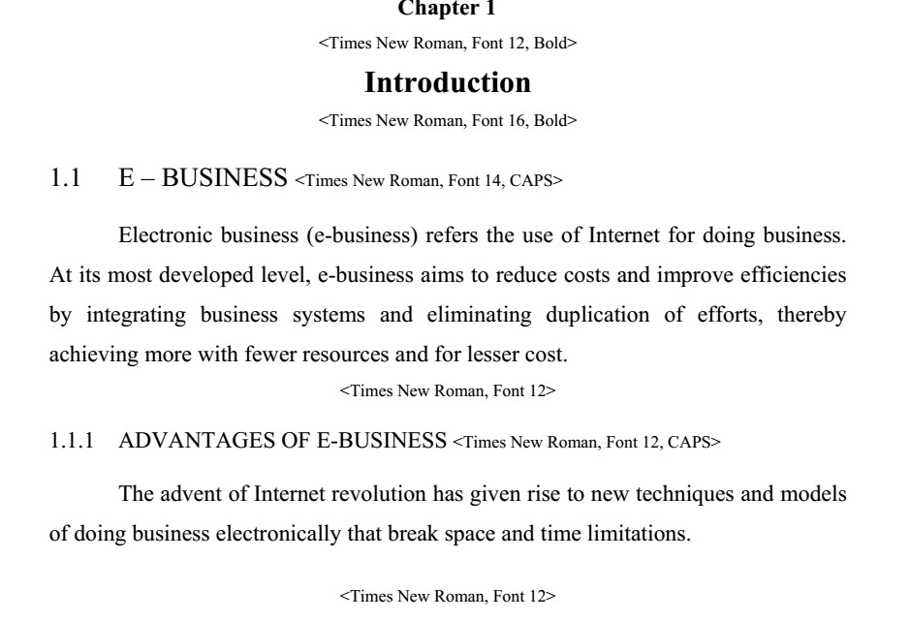



1
Chapter n


< Times New Roman, Font 12, Bold>

Conclusion and Future Work


< Times New Roman, Font 16, Bold>

This chapter should summarize the key aspects of your project (failures as well as successes) and should state the conclusions you have been able to draw. Outline what you would do if given more time (future work). Try to pinpoint any insights your project uncovered that might not have been obvious at the outset. Discuss the success of the approach you adopted and the academic objectives you achieved. Avoid meaningless conclusions, [e.g. NOT “I learnt a lot about C++ programming”]. Be realistic about potential future work. Avoid the dreaded: “All the objectives have been met and the project has been a complete success”. You have to crisply state the main take-away points from your work. Describe how your project is performed against planned outputs and performance targets. Identify the benefits from the project. Be careful to distinguish what you have done from what was there already. It is also a good idea to point out how much more is waiting to be done in relation to a specific problem, or give suggestions for improvement or extensions to what you have done.
Future scope of the work for improvement may also be included

2


Appendices
< Times New Roman, Font 12, Bold>

Appendices are provided to give supplementary information, which is not included in the main text may serve as a separate part contributing to main theme.
    - Appendices should be numbered using Arabic numerals, e.g. Appendix 1, Appendix 2 etc.
    - Appendices, tables and references appearing in appendices should be numbered and referred to at appropriate places just as in the case of chapters.
    - Appendices shall carry the title of the work reported in it and the same title shall be used in the contents page also.

REFERENCES
<Times New Roman, Font 16, Bold, CAPS>
// (ALL REFERNCE SHOULD BE IN APA FORMAT)

[1]. Eckart, C. (1951). Surface waves on water of variable depth, Wave Rep. 100, Scripps Inst. of Oceanogr., Univ. of California, pp.99. <For referring reports> <Times New Roman, Font 12>

[2]. Hasselmann, K., W.H. Munk and G.J.F. MacDonald (1963). Bispectra of Ocean Waves, In: M. Rosenblatt (ed.), Time Series Analysis, John Wiley Sons, p. 125, NewYork. <For referring from books edited from a collection of different papers>. <Times New Roman, Font 12>

[3]. Stoker, J.J. (1957). Water Waves. Interscience, New York. p. 520.
<For referring book> <Times New Roman, Font 12>

[4]. Tatavarti, Rao V.S.N. and D.A. Huntley (1987). Wave reflection at Beaches. Proc. Canadian Coastal Conference, Quebec City, pp. 241-255, Canada. <Times New Roman, Font 12>
<For referring conference proceedings>
[5]. Wallace, J.M. and R.E. Dickinson (1972). Empirical orthogonal representation of time series in the frequency domain, Part I: Theoretical considerations, J. App. Meteorology, Vol. 11, No. 6, pp. 887-892. <For referring journals> <Times New Roman, Font 12>

